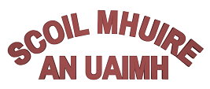

**Bí Cineálta Policy to Prevent and Address Bullying Behaviour**

The Board of Management of Scoil Mhuire Navan has adopted the following policy to prevent and address bullying behaviour.

This policy fully complies with the requirements of Bí Cineálta: *Procedures to Prevent and Address Bullying Behaviour for Primary and Post-Primary Schools* 2024.

The board of management acknowledges that bullying behaviour interferes with the rights of the child as set out in the United Nations Convention on the Rights of the Child. We all, as a school community, have a responsibility to work together to prevent and address bullying behaviour and to deal with the negative impact of bullying behaviour.

We are committed to ensuring that all students who attend our school are kept safe from harm and that the wellbeing of our students is at the forefront of everything that we do. We recognise the negative impact that bullying behaviour can have on the lives of our students and we are fully committed to preventing and addressing bullying behaviour.

We confirm that we will, in accordance with our obligations under equality legislation, take all such steps that are reasonably practicable to prevent the harassment of students or staff on any of the nine grounds specified: gender, civil status, family status, sexual orientation, religion, age, disability, race and membership of the Traveller community.

**Definition of bullying**

Bullying is defined in *Cineáltas: Action Plan on Bullying and Bí Cineálta: Procedures to Prevent and Address Bullying Behaviour for Primary and Post-Primary Schools* as targeted behaviour, online or offline that causes harm. The harm caused can be physical, social and/or emotional in nature. Bullying behaviour is repeated over time and involves an imbalance of power in relationships between two people or groups of people in society. The detailed definition is provided in Chapter 2 of the Bí Cineálta procedures.

Each school is required to develop and implement a Bí Cineálta policy that sets out how the school community prevents and addresses bullying behaviour. Strategies to deal with inappropriate behaviour that is not bullying behaviour are provided for within the school’s Code of Behaviour.

**Section A: Development/review of our Bi Cineálta Policy to Prevent and Address Bullying Behaviour**

All members of our school community were provided with the opportunity to input into the development/review of this policy.

|  |  |  |
| --- | --- | --- |
|  | Date Consulted | Method of Consultation |
| School staff | March-May 2025 | Staff Meetings/ Croke Park hours |
| Students | May 2025 | Questionnaires |
| Parents | May 2025 | Questionnaires/focus groups |
| Board of Management  Wider school community as appropriate for example, bus drivers | June 2025 | Meetings/ distribution of policy |

|  |
| --- |
| Date policy was approved: 4th June 2025 |
| Date by which policy was is to be reviewed: 4th June 2026 |

**Section B: Preventing Bullying Behaviour**

|  |
| --- |
| This section sets out the prevention strategies that will be used by the school. These include strategies specifically aimed at preventing online bullying behaviour, homophobic and transphobic bullying behaviour, racist bullying behaviour, sexist bullying behaviour and sexual harassment as appropriate (see Chapter 5 of the Bí Cineálta procedures):   * Trusting relationships between children and staff members based on respect, care and integrity * The concept of a ‘trusted adult’ is one that the school will encourage. Children should be encouraged to think about who they would tell in school if they were experiencing bullying * The school leadership team influences the school culture and sets the expectations when preventing and addressing bullying behaviour * Each member of the school staff has a responsibility to develop and maintain a school culture where bullying behaviour is unacceptable a to take a consistent approach to addressing bullying behaviour * Kindness and inclusion should be promoted among the students * Parents should also foster an environment where bullying behaviour is not tolerated through promoting empathy and respect * It is important that the school supports a ‘telling’ environment * Online Safety Training offered to parents through a variety of methods * Online Safety Training will be delivered from 2nd to 6th class on a yearly basis * SPHE programme will be taught in all classes on a yearly basis to educate the children on bullying behaviours and actions to take if they are experiencing bullying   The school has the following supervision and monitoring policies in place to prevent and address bullying behaviour (see Chapter 5 of the Bí Cineálta procedures)   * Appropriate supervision will be provided on the yard and in the school at breaktime * The school will offer a mix of organised activities during break-times. These will accommodate a range of preferences and interests * The school will work to ensure that staff have good visibility when supervising at break times including yard duty |

**Section C: Addressing Bullying Behaviour**

The teacher(s) with responsibility for addressing bullying behaviour are all teachers in the school.

When bullying behaviour occurs, the school will:

* ensure that the student experiencing bullying behaviour is heard and reassured
* seek to ensure the privacy of those involved
* conduct all conversations with sensitivity
* consider the age and ability of those involved
* listen to the views of the student who is experiencing the bullying behaviour as to how best to address the situation
* take action in a timely manner
* Listen to the child doing the bullying. Explain process and consequences
* inform parents of those involved

|  |
| --- |
| The steps that will be taken by the school to determine if bullying behaviour has occurred, the approaches taken to address the bullying behaviour and to review progress are as follows (see Chapter 6 of the Bí Cineálta procedures):  To determine whether the behaviour reported is bullying behaviour the school will consider the following questions:   1. Is the behaviour targeted at a specific student or group of students? 2. Is the behaviour intended to cause physical, social or emotional harm? 3. Is the behaviour repeated?   If the answer to each of the questions above is Yes, then the behaviour is bullying behaviour and the behaviour should be addressed using the Bí Cineálta Procedures.  **Note: One-­off incidents may be considered bullying in certain circumstances. A single hurtful message posted on social media can be considered bullying behaviour as it has a high likelihood of being shared multiple times and thus becomes a repeated behaviour.**  If the answer to any of these questions is **No,** then the behaviour is not bullying behaviour.  Strategies to deal with inappropriate behaviour are provided for within the school’s Code of Behaviour. When identifying if bullying behaviour has occurred teachers should consider what, where, when and why?   * if a group of students is involved, each student should be engaged with individually at first * thereafter, all students involved should be met as a group * at the group meeting, each student should be asked for their account of what happened to ensure that everyone in the group is clear about each other’s views * each student should be supported as appropriate, following the group meeting * it may be helpful to ask the students involved to write down their account of the incident(s)   **Where bullying behaviour has occurred**   * parents are an integral part of the school community and play an important role, in partnership with schools, in addressing bullying behaviour. Where bullying behaviour has occurred, the parents of the students involved must be contacted at an early stage to inform them of the matter and to consult with them on the actions to be taken to address the behaviour * it is important to listen to the views of the student who is experiencing the bullying behaviour as to how best to address the situation * a record should be kept of the engagement with all involved * this record should document the form and type of bullying behaviour, if known (see Section 2.5 and 2.7 of the Bi Cineálta procedures), where and when it took place and the date of the initial engagement with the students involved and their parents > the record should include the views of the students and their parents regarding the actions to be taken to address the bullying behaviour |

|  |
| --- |
| The school will use the following approaches to support those who experience, witness and display bullying behaviour (see Chapter 6 of the Bí Cineálta procedures):   * the teacher must engage with the students involved and their parents again no more than 20 school days after the initial engagement * important factors to consider as part of this engagement are the nature of the bullying behaviour, the effectiveness of the strategies used to address the bullying behaviour and the relationship between the students involved * the teacher should document the review with students and their parents to determine if the bullying behaviour has ceased and the views of students and their parents in relation to this * the date that it has been determined that the bullying behaviour has ceased should also be recorded * any engagement with external services/supports should also be noted * ongoing supervision and support may be needed for the students involved even where bullying behaviour has ceased * if the bullying behaviour has not ceased the teacher should review the strategies used in consultation with the students involved and their parents. A timeframe should be agreed for further engagement until the bullying behaviour has ceased * if it becomes clear that the student who is displaying the bullying behaviour is continuing to display the behaviour, then the school consideration should be given to using the strategies to deal with inappropriate behaviour as provided for within the school’s Code of Behaviour. If disciplinary sanctions are considered, this is a matter between the relevant student, their parents and the school * if a parent(s) is not satisfied with how the bullying behaviour has been addressed by the school, in accordance with the Bí Cineálta Procedures to Prevent and Address Bullying Behaviour for Primary and Post-Primary Schools. they should be referred to the school’s complaints procedures * if a parent is dissatisfied with how a complaint has been handled, they may make a complaint to the Ombudsman for Children if they believe that the school’s actions have had a negative effect on the student |

All bullying behaviour will be recorded. This will include the type of behaviour, where and when it took place, and the date of the engagement with students and parents. The actions and supports agreed to address bullying behaviour will be documented. If the bullying behaviour is a child protection concern the matter will be addressed without delay in accordance with *Child Protection Procedures for Primary and Post-Primary Schools.*

**Section D: Oversight**

The principal will present an update on bullying behaviour at each board of management meeting. This update will include the number of incidents of bullying behaviour that have been reported since the last meeting, the number of ongoing incidents and the total number of incidents since the beginning of the school year. Where incidents of bullying behaviour have occurred, the principal will also provide a verbal update which will include where relevant, information relating to trends and patterns identified, strategies used to address the bullying behaviour and any wider strategies to prevent and address bullying behaviour where relevant. This update does not contain personal or identifying information. See Chapter 7 of the Bí Cineálta procedures.

This policy is available to our school community on the school’s website and in hard copy on request. A student friendly version of this policy is displayed in the school and is also available on our website and in hard copy on request.

This policy and its implementation will be reviewed, following input from our school community, each calendar year or as soon as practicable after there has been a material change in any matter to which this policy refers.

Signed: Michael Lynch Date: 5th June 2025

(Chairperson of board of management)

Signed: Fiona Hayden Date:5th June 2025

(Principal)

|  |
| --- |
| **Bí Cineálta!**  **We want everyone at our school to feel safe and happy.**    **If you think that you are being bullied or someone else is being bullied, you need to tell a teacher or another adult that you trust. They will know what to do to help.**  **Get help!**  **Tell someone!**    If a student tells a staff member that they think they are being bullied, we will:  > talk with the student  > ask the student what they want to happen  > work out a plan together  > talk to their parents  > talk to the other student(s) involved  > talk with the other student’s parents |

Appendix 1: Student Friendly Version of Bí Cineálta Policy

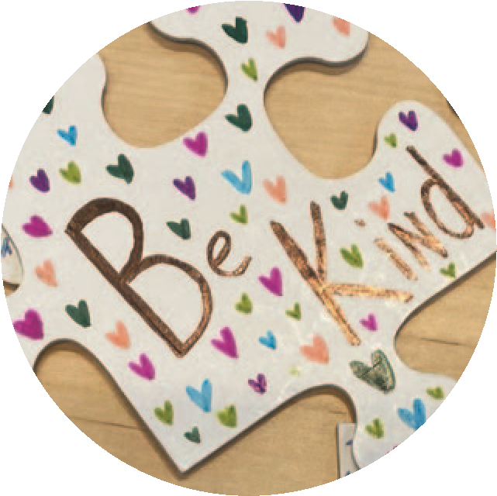

Our school

has a Bí Cineálta policy to try

to stop bullying behaviour.

We look at this policy every year to

see what is working well or what could

work be

琀

er.

We will ask you what

you think.

Please

tell someone if you

think that you are

being bullied or

someone else is

being bullied.

When it happens a lot.

Not just once.

# Appendix 2: Template for recording bullying behaviour

1. **Name of pupil being bullied and class group**

Name _________________________________________Class__________________

1. **Name(s) and class(es) of pupil(s) engaged in bullying behaviour**

1. **Source** of bullying concern/report

|  |  |
| --- | --- |
| Pupil concerned |  |
| Other Pupil |  |
| Parent |  |
| Teacher |  |
| Other |  |

**4. Location** of incidents (tick

(tick relevant box(es))*

|  |  |
| --- | --- |
| Playground |  |
| Classroom |  |
| Corridor |  |
| Toilets |  |
| School Bus |  |
| Other |  |

1. **Name of person(s) who reported** the bullying concern

|  |
| --- |
|  |

1. **Type** of Bullying Behaviour (tick relevant box(es)) *

|  |  |  |  |
| --- | --- | --- | --- |
| Physical Aggression |  | Cyber-bullying |  |
| Damage to Property |  | Intimidation |  |
| Isolation/Exclusion |  | Malicious Gossip |  |
| Name Calling |  | Other (specify) |  |

1. **Where behaviour is regarded as identity-based bullying, indicate the relevant category:**

|  |  |  |  |  |
| --- | --- | --- | --- | --- |
| Homophobic | Disability/SEN related | Racist | Membership of  Traveller community | Other (specify) |
|  |  |  |  |  |

1. **Brief Description of bullying behaviour and its impact**

|  |
| --- |
|  |

1. **Name of person(s) who reported** the bullying concern

|  |
| --- |
|  |

1. **Type** of Bullying Behaviour (tick relevant box(es)) *

|  |  |  |  |
| --- | --- | --- | --- |
| Physical Aggression |  | Cyber-bullying |  |
| Damage to Property |  | Intimidation |  |
| Isolation/Exclusion |  | Malicious Gossip |  |
| Name Calling |  | Other (specify) |  |

1. **Where behaviour is regarded as identity-based bullying, indicate the relevant category:**

|  |  |  |  |  |
| --- | --- | --- | --- | --- |
| Homophobic | Disability/SEN related | Racist | Membership of  Traveller community | Other (specify) |
|  |  |  |  |  |

1. **Brief Description of bullying behaviour and its impact**

|  |
| --- |
|  |

1. **Details of actions taken**

|  |
| --- |
|  |

Signed ______________________________ (Relevant Teacher)

Date ___________________________

|  |  |  |  |
| --- | --- | --- | --- |
| Playground |  |  |  |
| Classroom |  |  |  |
| Corridor |  |  |  |
| Toilets |  |  |  |
| School Bus |  |  |  |
|  |  |  |  |